Winchelsea Primary School
Reading Policy
Intent
At Winchelsea Primary School, our reading curriculum aims to instil a lifelong love of reading in every child by developing confident, curious, and passionate readers. We believe reading opens the doorway to children understanding and accessing the wider world whilst unlocking their potential and enabling on-going learning.
We strive to teach children to become fluent, confident and able readers, who enjoy reading a wide range of texts. Our reading curriculum provides opportunities for children to practise and embed their reading skills. They will ‘learn to read’ and then ‘read to learn’. Our consistently high expectations ensure that, through challenge and support, all learners will see themselves as readers and reach their full potential.
Our children’s reading journey, and the texts within it, has been carefully planned and sequenced to ensure that they encounter and understand different cultures, genres, and perspectives. By exposing children to stories from a variety of cultures, we help them develop empathy and an appreciation for different voices and experiences.
Teachers are passionate about reading and seek to foster a love of reading in all our children. We encourage our children to develop the habit of reading widely and often, for both pleasure and information.

Implementation
Phonics
At Winchelsea we follow the ‘Read, Write, Inc” program for teaching phonics. This is taught from Diamond class (Reception), through year 1 and into year 2 and beyond as needed. This is a complete systematic synthetic phonics programme (SSP).
- Daily lessons: RWI is taught daily to children in EYFS, Year 1, and Year 2.
- Ability grouping
- Partner work
- Continuous provision
- Daily one-to-one tutoring for those making slower progress
- Assessment and review: in lesson, periodic formal assessment and half termly reviews to establish next steps.
- Addressing specific needs
- Support for struggling readers, including in older year groups
- Support for SEN and able pupils

Beyond Phonics
From Year 2 onwards, when children have completed the Read, Write Inc phonics scheme, reading is taught through a mixture of whole class teaching and enhancement groups.
Reading lessons take place at least four times a week for 30 minutes at the beginning of English sessions. These lessons are guided by the following principles:
- Enjoyment – Share and explore challenging texts with enthusiasm.
- Text-Led Approach – Let the text shape the discussion and learning.
- Rich Discussions – Encourage thoughtful conversations about texts.
- High Expectations for All – Challenge pupils while providing necessary support.
- Personal Engagement – Foster individual responses to texts.
- Variety – Use a diverse range of teaching approaches and activities.
- Integrated Learning – Connect reading with writing and grammar
Comprehension strategies are explicitly taught through active engagement with carefully selected texts from our personalised reading spine.
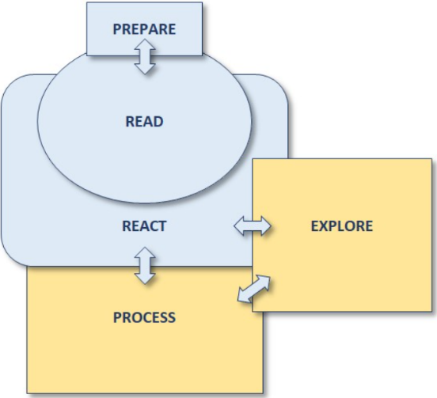
The following structure is used when planning a sequence of learning:

As a minimum, each lesson will include the stages of prepare, read and react. Throughout the learning sequence, children will also have opportunities to process their responses and understanding, as well as explore the text by reading closely for comprehension or to analyse language, meanings and effects. Our approach invites children to become real readers.

Fluency
Fluent reading supports reading comprehension. When pupils read fluently, their cognitive resources can be redirected from focusing on decoding and onto comprehending the text. For this reason, fluency is sometimes described as a bridge from word recognition to comprehension (EEF). Therefore, at our school developing reading fluency is a top priority,
- Every reading session includes dedicated time to develop fluency, using strategies such as echo reading, choral reading, and repeated reading.
- Children have frequent opportunities to read aloud, as well as to listen to adults model expressive reading. Daily story time takes place in every classroom.
- The 6Ps - pace, passion, pause, pitch, punctuation, and power - are embedded in reading fluency teaching and are referenced in teacher feedback and peer discussions.
- Targeted 1:1 reading support is provided for children who need additional assistance. These sessions focus on fluency development through guided oral instruction and feedback to support progress.
This approach ensures that all pupils become confident, expressive, and fluent readers.

Vocabulary
We recognise the importance in setting children up for success and getting them into the ‘territory of the text’ (James Durran) and the vital role vocabulary plays in this.
Within the ‘prepare’ stage of teaching, teachers identify new difficult vocabulary to pre-teach to ensure that all children have the necessary skills to unpick word meanings in context when unsupported by an adult. New vocabulary is then revisited throughout the teaching sequences to ensure it becomes embedded within their long-term memory and applied in different contexts.

Assessment
Children are assessed throughout the year to monitor progress and enable teachers to address any gaps in learning and identify where support is needed.
- Formative assessments of a child’s reading ability are made regularly during one-to-one reading sessions, small group work and whole class teaching of reading skills.
- Children are assessed on their fluency using a Fluency Rubric (developed by Dr Tim Rasinski) each term.
- Termly, summative comprehension assessments are held as part of the whole school assessment process, using NFER materials and national assessment papers.
- Children beyond phonics are assessed every half term using Accelerated Reader and this levels each child’s reading and comprehension abilities.
This gives the teacher a comprehensive overview of their abilities alongside their own judgements, experience and classroom assessments. This information identifies the level of book that is appropriate for each child’s individual reading.
- Children in EYFS and Year 1 are assessed using Read, Write Inc assessments every term to help keep all children on track, map progress and identify those at risk of falling behind. For some children, Phonics assessment and interventions are carried out into year 2 where needed.
Accelerated Reader books give each child a level range, from which they choose from a wide range of books, both fiction and non-fiction, within their ‘zone of proximal development’ (the ZPD is a range of book levels that are not too challenging and not too easy- depending upon a child’s reading level).
We also allow children opportunities to free choose a book, as we recognise the importance of celebrating children’s individual reading preferences and the process of becoming their own reader.

Encouraging a ‘Love of Reading’
At Winchelsea, we believe that fostering a lifelong love of reading is incredibly important, and so we celebrate reading at every opportunity possible. Children leave our school with a real enthusiasm for the written word, eager to pick up a book and delve into everything it has to offer. Reading should be carried out not only for academic success but also for a child’s own enjoyment and personal growth.
At Winchelsea:
- Children have access to a wide range of high-quality books; fiction, nonfiction, poetry, comics and magazines to choose from. They are encouraged to share their favourite books and recommend both fiction and non-fiction titles. Wherever possible, these books are made available in our library areas
- Each class enjoys a story that is shared by their teacher, and this is timetabled in daily.
- We ensure that, as a staff, we are passionate and knowledge about children’s literature and have a good knowledge of the children’s reading practices.
- We work hard to develop links with the local community library, including visits to the library to encourage reading and a love of books outside of the school walls. We support and encourage children to take part in the local library’s summer reading challenge each year.
- Winchelsea staff work hard to engage with our parents, and we firmly believe that learning to read, and developing a love of reading is a process that is only truly successfully when carried out at home as well as in school. With this in mind, we provide phonics workshops in year 1 to help parents best understand how to support early readers.
- We love to celebrate World Book Day, hold Book Fairs and we provide regular classroom time for children to pursue their own reading. We also enjoy inviting authors into school to inspire our pupils with their reading and writing.
- The school is signed up to the Lincolnshire Reading Pledge

Impact
At Winchelsea Primary School, we are committed to ensuring that every child develops the skills, appreciation, and understanding needed to confidently access the written word. Reading is fundamental to success across the curriculum, supporting learning in all subjects and preparing children for the next stage of their education.
We foster a love of reading by encouraging children to read widely and often, helping them become well-rounded individuals with a lifelong passion for literature. We believe that strong reading skills open doors to future opportunities, enriching children's lives both academically and personally.
The impact of our reading curriculum is evident in formative classroom assessments, termly progress data, and end-of-year evaluations, including the statutory assessments at the end of Key Stages 1 and 2. Winchelsea has a strong track record of ensuring that every child makes positive progress in both fluency and comprehension. Our pupils develop the confidence and enthusiasm to engage with a wide range of texts for both enjoyment and learning.
By the time they leave Winchelsea, our children are equipped not only to succeed in their education but also to embrace the lifelong benefits of reading, ensuring that our curriculum extends beyond assessments to support their future success.

