Dear Parents and Year 1 children,
This term….

Our PE days are a Wednesday and Thursday. Please ensure your child has appropriate clothing with them as some of our PE sessions will be outside.

On Friday’s we will continue to spend some time at Forest School. It is vital that you send your child with a spare change of clothes, wellies and a coat each week.

Parents evening- 30th and 31st March
Parent invite- 2nd April at 14:45pm

As mathematicians we are focussing on:

Place value

Measurement

In PE:
Mrs Houlden will be helping the children improve their multi- skills in PE this term.

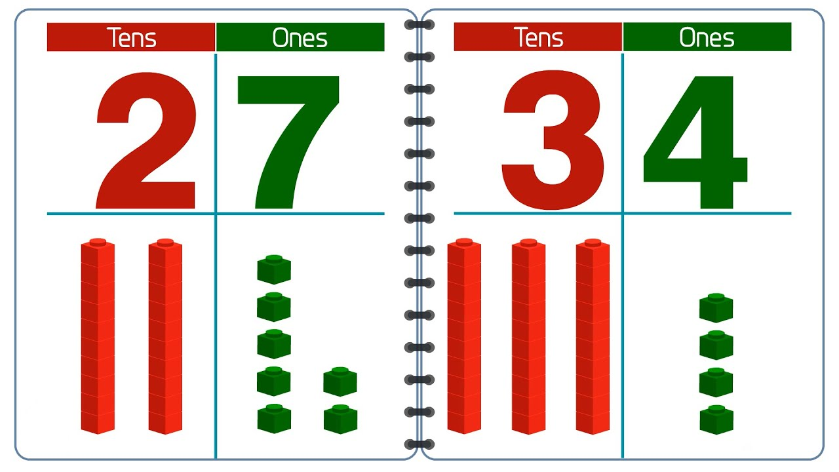

In D&T:

This term in D&T we will be making smoothies and learning about healthy eating.

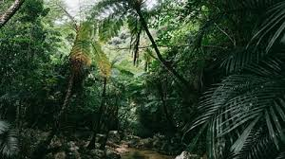
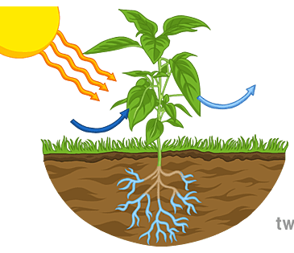






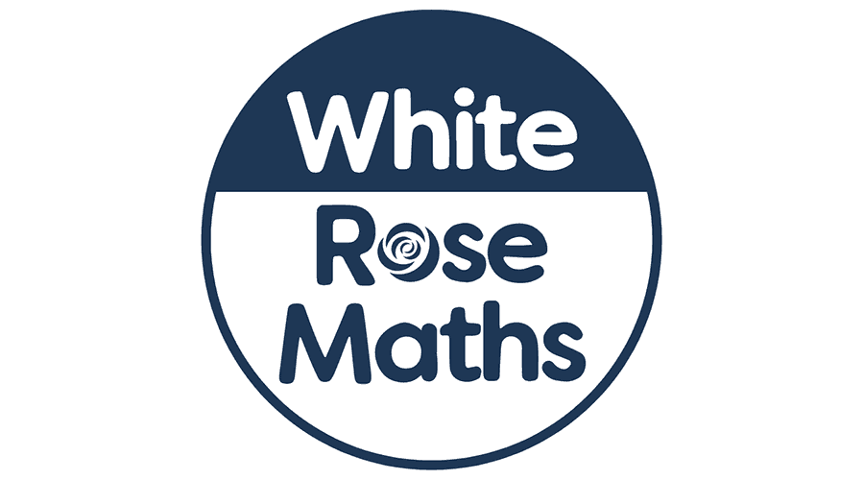


In RE:

Our big question in RE this term is…

What do creation stories teach people about God and human nature?

In PSHE:

This term in PSHE we are focussing on citizenship.
In science:

In Science this term we are learning all about plants.

We will be focussing on how plants grow and the different parts of a plant.
We are looking at jungles around the world.
We will be comparing a jungle to the woodlands in our local area.
In music:

This term, the children will
experiment with composition, creating soundscapes to
demonstrate their understanding.
In computing:

In computing this term we are focussing on grouping data and information.
Reading and writing:

We will be delivering Read Write Inc phonics. This includes teaching of phonics, reading, writing and spelling.

In humanities:

Winchelsea Primary School
‘All individuals matter’

