Dear Parents and Year 5 children,

Welcome to the second spring term. PE is Tuesday and Thursday where possible – although this can sometimes be disrupted, so please ensure PE kits are in all week.

Homework will be handed out on Thursday and due in on Monday.
Children will also have weekly spellings on EdShed and times tables ongoing.
Please feel free to chat to Miss Reid at the beginning or the end of the day should you have any queries.

Alternatively, contact the office for an appointment! 😊
As readers and writers we will:
…discovering the book: Boy in the Tower. This book sounds like a straightforward science-fiction tale, in which Day of the Triffids style plants consume buildings and cast out deadly spores. In fact, it reads more like a fable about friendship, loyalty and bravery!
Children are expected to read 20 minutes a night – please help us in encouraging this!
All children are expected to read out loud to an adult at least once a week - this will help their fluency and expression.

We hope you enjoy this time with your child too!

As mathematicians we will:
Learning about decimals and percentages
and how they are similar to fractions.
We’ll move on to perimeter and area
at the end of the term

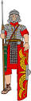


Winchelsea Primary School
‘All individuals matter’



Dates:
Parent Engagement:
24th March 2:45pm

Easter: Fri 3rd March



As scientists we will:
continue learning about Space (as requested by the children!). The children have loved the topic and are keen to learn some more!

We will also be learning about the properties of materials, including learning about solids liquids and gases!
In Art, we will be… completing the topic:
“Drawing: Depth, emotion and movement”
In this theme, we’ll be exploring mark
making for showing depth, emotion and
movement.

In PSHE, we will be… learning about keeping ourselves safe and the changing body.
In French, we will be… learning all about space- mais en français! And then we’ll be looking at shopping!




In ICT, we will be… learning about video production! We will learn how to create short videos in groups.
As we progress through this unit, the children will be exposed to topic-based language and
develop the skills of capturing, editing, and manipulating video.
In history, we will be…
Finishing our Mayan topic

In geography, we will be…
Studying all about Mountains!

The children will be thinking about how they’re made, their features and some
important mountains and ranges
both in the UK and around
the world.
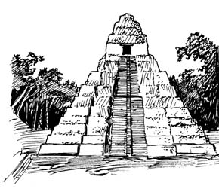




In music, we will continue to explore film music, analysing how soundtracks enhance storytelling by identifying musical elements for characters, emotions, and moods. They will compose themes reflecting various characters, emotions, and dramatic moments.




