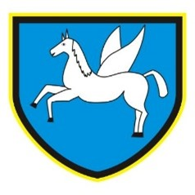
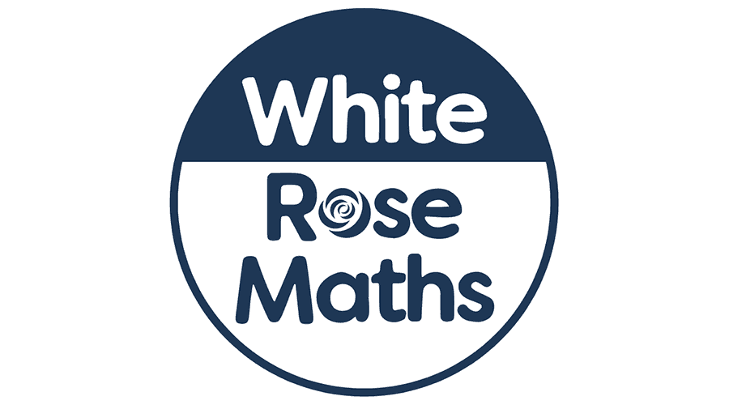
Amethyst Class, Summer, 2026
Dear Parents,
This final (where has all the time gone?) term promises to be just as exciting as previous ones. The pupils learning journey will continue with some new and informative areas of study ahead.
Our PE days this half term will be on a Tuesday and Wednesday. Swimming will take place this term from Tuesday 23rd June. Information will be emailed to you.
Our parent event will be school sports day on 15TH July.

As mathematicians we will:
Look at how we measure time,
using both analogue and digital clocks.
In Amethyst we will use a range of learning games to help with our quick recall of multiplication facts. Such as;
https://play.ttrockstars.com/auth/school 

In arts, we will be exploring and reproducing our own ancient scroll – connected to our history topic work.
With Mr Roberts the children will use a range of instruments when playing a collective piece of music.
As readers we will:
Examine the various text examples to see how an information text is constructed.
We will comment on the structure of various texts and examine how non-fiction books are used to provide us with information.

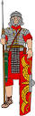
Winchelsea Primary School
‘All individuals matter’

In humanities, we will be looking at Ancient Greece and how this civilisation has shaped the modern world through the advent of theatre and the birth of democracy.

Our PSHE lessons this half term will focus on rights and responsibilities.
In RE we will look at a school-based study linked to the Narnia books.
Our French lessons will look at phrases for stating where we live.

Our exciting class text this term is ‘The Iron Man’ by Ted Hughes.
Science
We will continue our investigations with regards plants and animals. Prepare for some more garden surveys as a homework tasks!

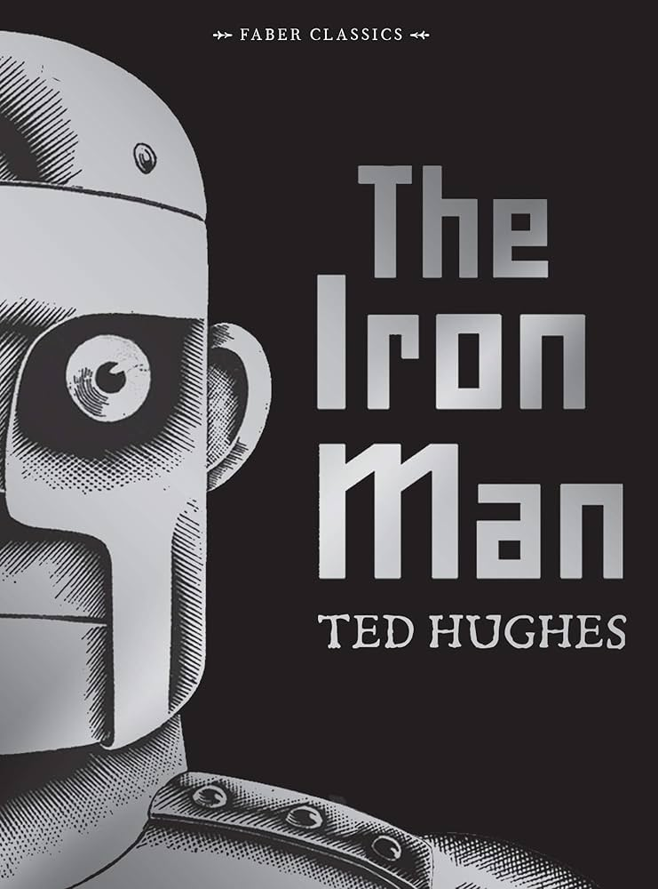
As young writers we will look at how we can create informative pieces of work. In this final term we will be writing non-chronological reports on subjects which the children find interesting.

