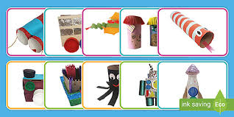
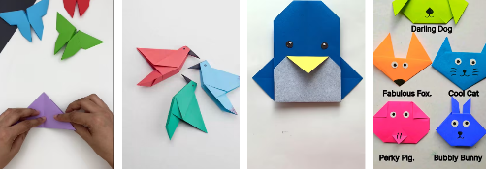
P.E.- Make a fitness circuit for your family to all have a go.
English- To write a few sentences about what you did in the holidays. Remember fingers spaces, capital letters and full stops.
Geography.- Take a walk around your local area and list all the human made things you see and natural items. Is your area urban or rural?
Maths- Create groups of items at home and count them.
Art- Origami
Make a 3D object out of paper. You can follow instructions via YouTube.
Art- 3D Model
Can you make a 3D sculpture with play dough or any other objects in the house. It could be a junk model…
Science- Poster
Make a poster all about your favourite animal.
Autumn Term Homework
Science- Anatomist
Compare the size of your families’ hands by drawing round them and measuring them, make some statements about what you find e.g. my sisters hand was the smallest.

Music- Using either an instrument at home, your hands, voice or if allowed kitchen utensils (ask for permission). Create the beat of your favourite song.
R.E.- Create a poster detailing Islam facts.
This could be using a computer or pencil and paper.
D and T- Healthy Diet
To make a colourful healthy dinner with help from your adult. Send a picture or bring a picture to show me. Yum!

